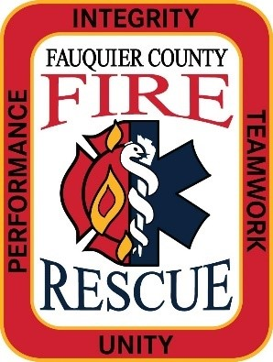

Fauquier County Fire and Rescue System After Action Report

[Event Title]
Incident #
[Address]
[Date]

Click or tap here to enter text.

Table of Contents
General Incident Information 3
Specific Incident Information 4
Investigation Team Methodology 5
Specific Incident Summary 5
Specific Incident Findings 5
Corrective Actions 5
Conclusions 6
Additional Findings 6
Photos/Diagrams 6

Lead Investigator: Click or tap here to enter text.
Investigation Team: Click or tap here to enter text.

General Incident Information
Incident Date: Click or tap here to enter text.
Incident Number: Click or tap here to enter text.
Address: Click or tap here to enter text.
Initial Response: Click or tap here to enter text.
Upgraded Response: Click or tap here to enter text.
RIT Dispatch: Click or tap here to enter text.
Additional Units: Click or tap here to enter text.
Incident Timeline
911 call received at the ECC

Specific Incident Information

Unit Assigned: Click or tap here to enter text.
Riding Position: Click or tap here to enter text.
Time of Incident: Click or tap here to enter text.
Were there any injuries because of the incident? Click or tap here to enter text.
Was the injured party treated at a medical facility? Click or tap here to enter text.
On the same day as the injury? Click or tap here to enter text.
Name/Location of medical facility: Click or tap here to enter text.
Was the injured party hospitalized overnight? Click or tap here to enter text.
What was the firefighter doing just before the incident occurred? Click or tap here to enter text.
What happened? Click or tap here to enter text.

Investigation Team Methodology
On date, Chief Name empaneled a work group to review the circumstances surrounding the incident, identify factors that may have contributed to the incident, as well as any lessons learned from which our System can benefit. To provide a fact-based report with relevant and supported recommendations, the team completed the following:
- Review of 911 tapes.
- Review of CAD notes.
- Requested personnel from Units to provide memos concerning their actions and recollections from the incident. All memos were reviewed by the team and a timeline was developed and cross-referenced against the CAD notes.
- As a follow up to the memos, team members interviewed crews/individuals.
- Review of System Wide Policies, FCFR Standard Operating Procedures, and NOVA Manuals.

Specific Incident Summary
Click or tap here to enter text.

Specific Incident Findings
Click or tap here to enter text.

Corrective Actions
Corrective Action(s) | Result(s)
1. Click or tap here to enter text. | Result 1a. Click or tap here to enter text.
2. Click or tap here to enter text. | Result 2a. Click or tap here to enter text.
3. Click or tap here to enter text. | Result 3a. Click or tap here to enter text.
4. Click or tap here to enter text. | Result 4a. Click or tap here to enter text.
5. Click or tap here to enter text. | Result 5a. Click or tap here to enter text.

Conclusions
Click or tap here to enter text.

Additional Findings
While the work done to complete this investigation focused on the specific event, there were other items that came to light because of the team’s work.
Click or tap here to enter text.

Photos/Diagrams

Click or tap here to enter text.

